Workflow for bidding a service on twoplugs.com

---------------------------------------------------------

Requirement:

The New Bid message page will now have 3 buttons. See 3.png

Decline Bid button should work like it currently works for "Deny Bid" button

Accept button should work like it currently works for "Confirm" button

Make an offer is the new button. When clicked should open the pop up. See 1.png

The seller should be able to enter a new price and a message. Message is optional. See 1.png

The seller will receive a new message Title " New Bid Offer" See 5.png

Same idea here. the seller will have 3 buttons: Decline Bid, Make an Offer, Accept. See 5.png

If the seller clicks on Make an Offer, then display the pop up in 1.png. and the process repeats

The buyer will also get a "New Bid Offer" message and the same process repeats

The process stops when seller or buyer pushes "Decline Bid" or "Accept"

As always make sure when there is a new message "New Bid Offer", ensure all "New Bid" messages about the same transaction are no longer active (i.e hide all the buttons). This is to prevent a user from accepting a "New Bid Offer" and also accepting an older "New Bid"

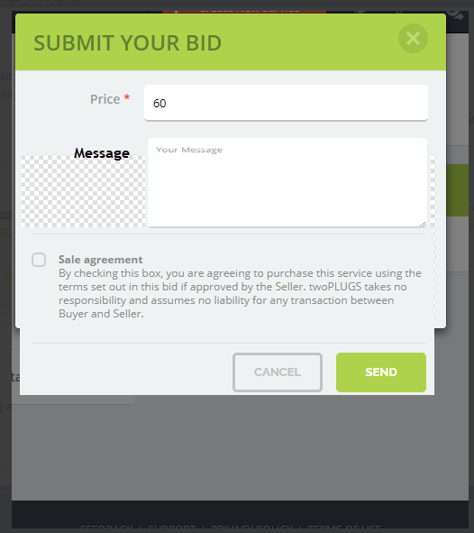

1.png

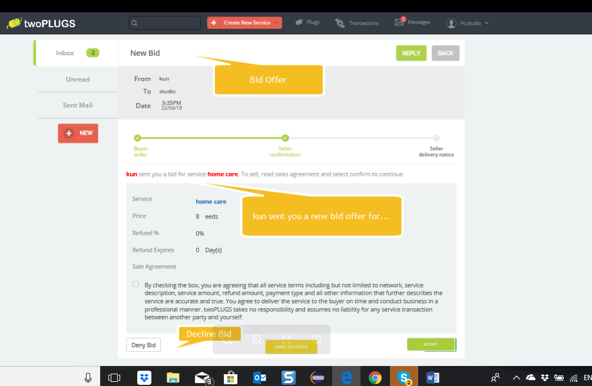

5.png

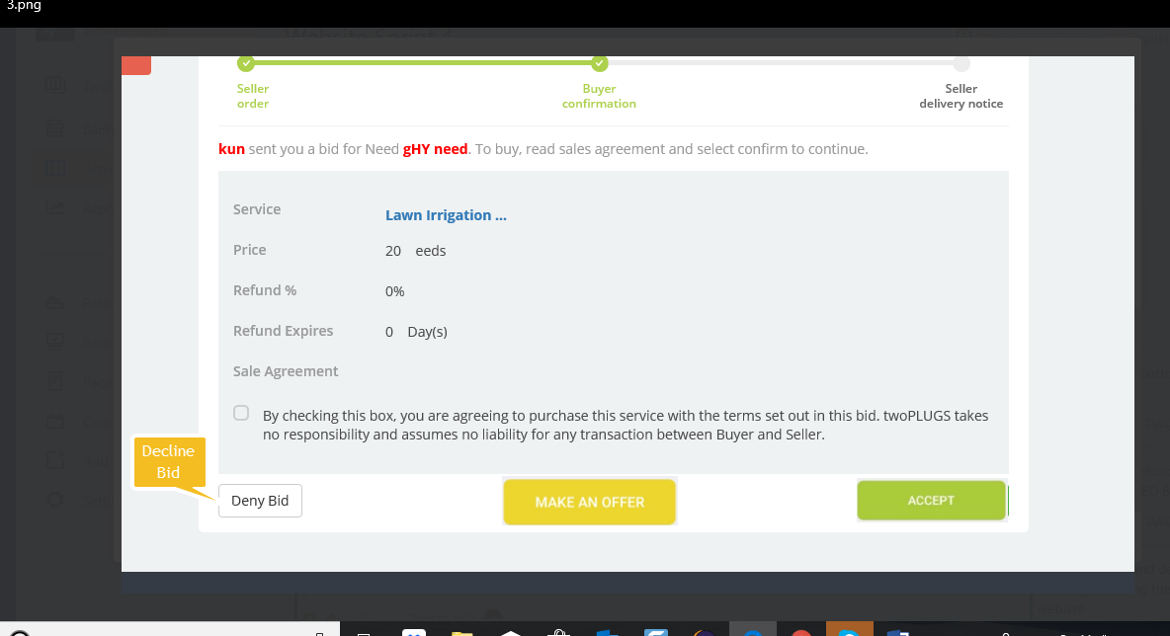

3.png